-- Verify that data exists in staging area
-- Row counts
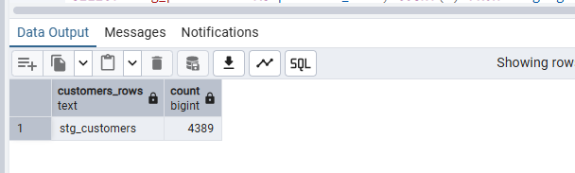
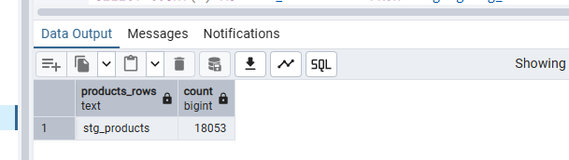

-- Check nulls in critical business keys
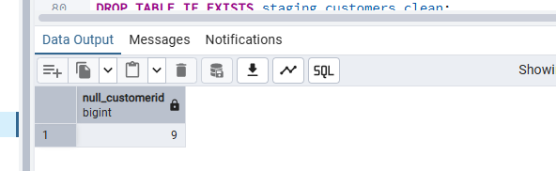
-- ============== PART 4: TRANSFORMATIONS (examples included) ==============
-- create cleaned / normalized intermediate (transform) tables in staging schema.
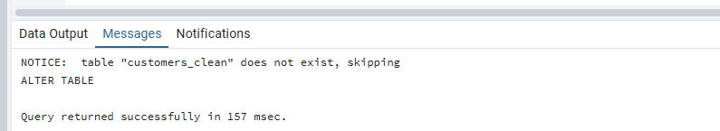
-- same goes with the other tables transformation done successfully

-- ============== PART 6: LOAD FACT (JOIN STAGING -> DIMENSIONS) ==============
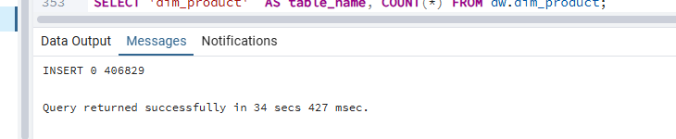
-- ============== PART 7: VALIDATION + EXAMPLES ==============
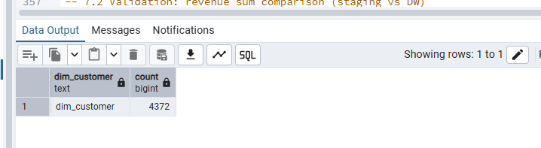
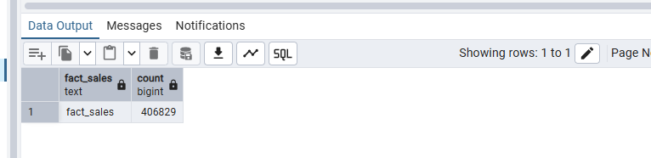

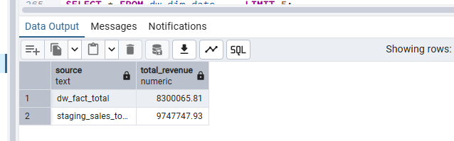

-- 7.3 Show some sample rows from each DW table
